Submit a Handwritten Assignment only.
SIR SYED UNIVERSITY OF ENGINEERING & TECHNOLOGY
COMPUTER SCIENCE & INFORMATION TECHNOLOGY DEPARTMENT

Fall 2024
Computer Networks (CS-317T)
Assignment # 3

Semester:V Batch: 2021F
Announced Date: 09-01-25 Due Date: 16-01-25
Total Marks: 4 Marks Obtained:
Instructor Name: Razia Nisar Noorani

CLO # | Course Learning Outcomes (CLOs) | PLO Mapping | Bloom’s Taxonomy
CLO 3 | Implement various internetworking devices and protocols and their functions in networks | PLO_3  (Problem Analysis) | C3  (Applying)

Question#1: Use Dijkstra’s algorithm for the following network to compute the shortest path
from the router x to all the other routers.

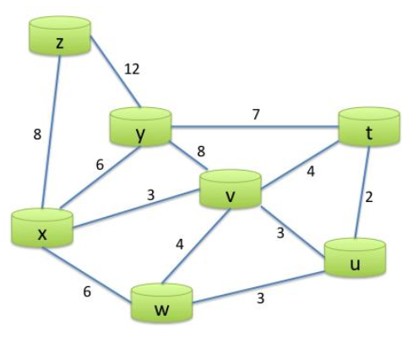
Question#2: Use the Bellman-Ford algorithm for the following network to compute DV for node ‘x’.

